Lab - Demonstrate the Growth of Data with VNI

1. Objective

Demonstrate the growth of data using Cisco’s Visual Networking Index (VNI) web site. Also, test cellular and Wi-Fi connection speed using Cisco’s Data Meter app.

Part 1: Cisco VNI Forecast Widget

Part 2: Cisco Data Meter Mobile App

1. Background/Scenario

In this lab, you will access the Cisco VNI Forecast Widget to view network traffic growth trends over a five-year period. You will select filters to limit or extend your search criteria. You will also use Cisco’s Data Metering app to test your Mobile device’s connection speeds.

1. Resources

* PC (OS X, Linux, Windows) with a connection to the Internet
* Android or iOS mobile device with Internet access

1. Cisco VNI Forecast Widget

Cisco has developed a forecast model to estimate future global IP traffic growth. The current Cisco VNI Forecast and Methodology 2015 – 2020 is based on Cisco analysis and independent analysts' forecasts.

**Note**: Flash is required to view the graph in the Cisco VNI Forecast widget.

* 1. Access Cisco’s VNI Forecast widget.
     1. Navigate to Cisco’s VNI Forecast widget:

<http://www.cisco.com/c/dam/m/en_us/solutions/service-provider/vni-forecast-widget/forecast-widget/index.html>

* + 1. After reviewing the Projecting global IP traffic growth information, click **Use the Advanced Editor** button.

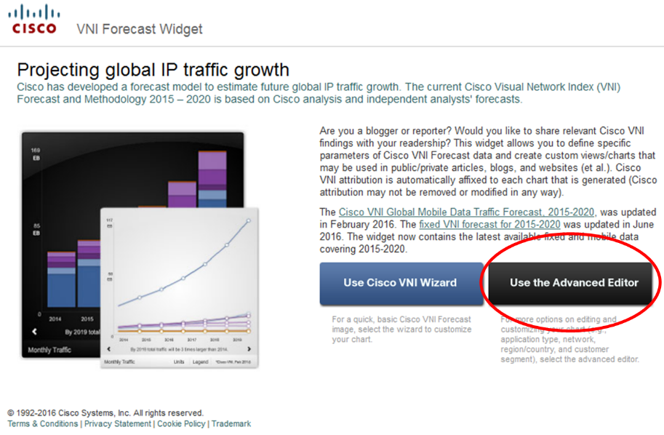

* 1. Use the Advanced Editor to change filter settings.

The Advanced Editor allows you to filter the data by Application Type, Network Type, Segment, and Country & Region. You also have options to change the Chart Type, Date Range, and Graphic Theme.

* + 1. To view only Mobile data, remove the **Fixed Internet** and **Managed IP** checkmarks under **Network Type**.

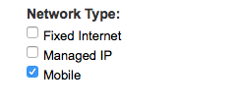

* + 1. Click **Uncheck All** under the Country & Region section, and then check the **Spain** checkbox.

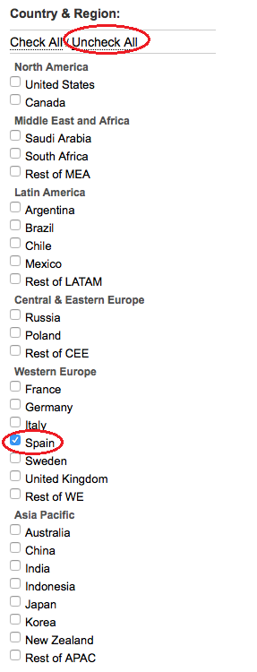

* + 1. The bar chart on the right displays the growth of mobile (smartphones and tablets) data over the five-year span from 2015 to 2020. Click the **Legend** button to view the color coding legend of the bars. Click the **Legend** button again to hide the legend.

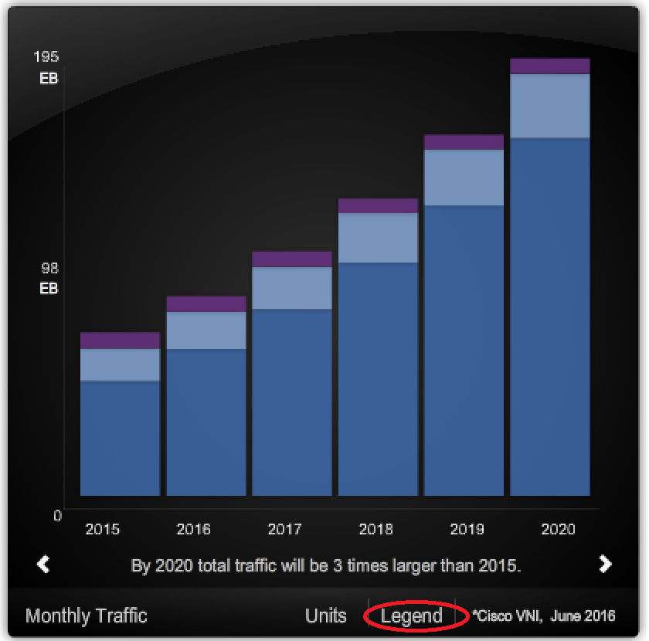

Define and sequence the following terms: Petabyte, Terabyte, and Exabyte.

____________________________________________________________________________________

How does Spain’s IP mobile traffic growth differ from your country’s growth?

____________________________________________________________________________________

1. Cisco Data Meter App

The free Cisco Data Meter app enables Apple and Android mobile device users to easily review their cellular and Wi-Fi data usage, test cellular and Wi-Fi connection speeds, and find nearby Wi-Fi hotspots.

**Note**: Part 2 is demonstrated using an Android device. Some screens and steps may be different when using an iOS or other device.

* 1. Download the Cisco Data Meter App.
     1. Navigate to the App Store for your mobile device and search for the Cisco Data Meter app.
     2. Download and install the Cisco Data Meter app.
  2. Open and use the Cisco Data Meter app.
     1. Open the Cisco Data Meter app. The Data at a Glance screen opens and displays the MONTH TO DATE cell usage. Swipe to the right. You may see the data usage BY APP or an ESTIMATE of how much data you may use for the month.

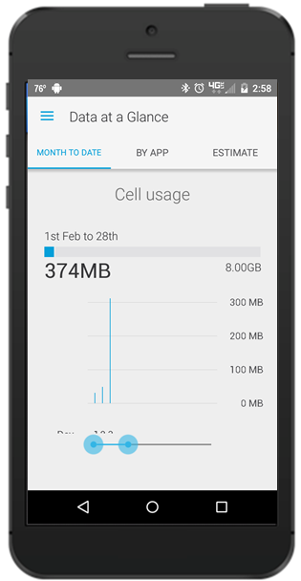 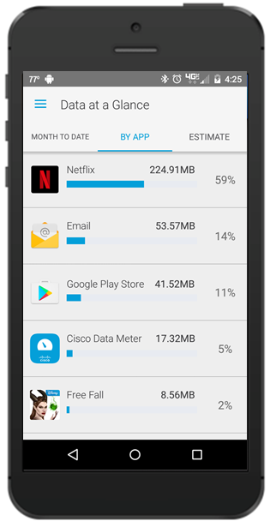 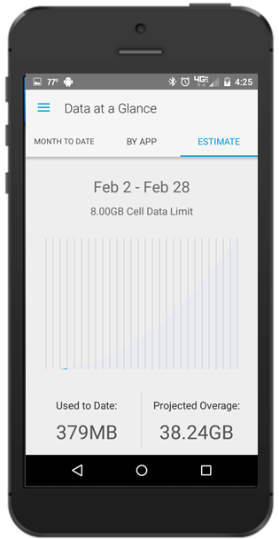

* + 1. Touch the menu icon () or swipe all way to the left for a list of options. Choose **Performing Speed Test**. Click **RUN TEST** to begin performing an active cell connection speed test. If you want to test the WI-FI connection, be sure WI-FI is enabled for your device.

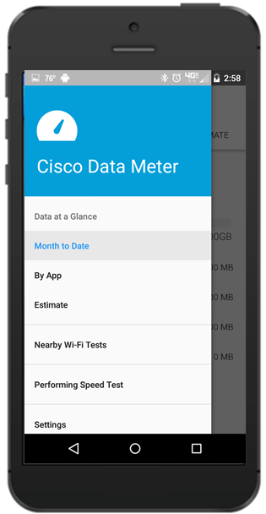 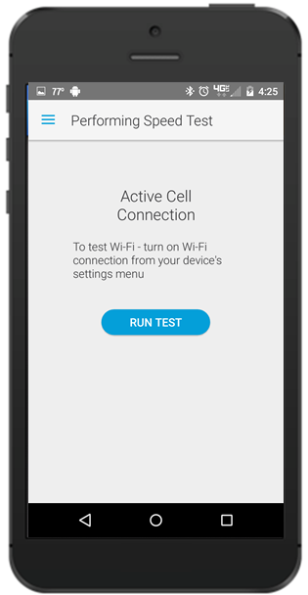

* + 1. With WI-FI enabled, touch the menu icon () or swipe all way to the left for a list of options. Select the **Nearby Wi-Fi** button to view a local map of available Wi-Fi networks in your area.

1. Reflection

Based on video growth trends shown in the VNI graph and the results from your Wi-Fi network test, do you feel that your current Wi-Fi network speed will be able to handle the expected additional traffic in 2020? Explain.

_______________________________________________________________________________________

_______________________________________________________________________________________

_______________________________________________________________________________________

_______________________________________________________________________________________